Summary
In Q3, OCI will implement the RAPID method, giving leadership a consistent approach to structuring cross-team business decisions, reducing the number of meetings, and launching new workstreams. RAPID is a process mechanism designed to help organizations make efficient, thorough, high-quality decisions. It is expected that consistently using RAPID creates the right conditions to understand decision roles and dependencies up front, reducing the overall number of meetings required for a given workstream. When a meeting is needed, RAPID helps us be more thoughtful in design, have focused intent and set clear expectations for tangible outcomes.
Problem Statement
Lack of decision structure results in inefficient and wasteful meetings, process rework, and administrative churn. In our current fast-moving operating environment, roles and processes are typically considered ‘iterative’; teams evolve organically, and decision ownership, priorities and dependencies can shift quickly. Legacy RACI models are oriented towards traditional, vertical org structures where roles and processes are relatively fixed, and decision-making authority consistently resides with the same individuals. To be efficient, OCI needs an agile, scalable mechanism to quickly and thoroughly make the right decisions.
Solution Overview
Implementing RAPID will help OCI by driving accountability and alignment in the decision-making process, empowering our organization to better plan their work and protect leaders’ time.
RAPID stand for “Recommend, Agree, Perform, Input, and Decide
- Recommend: A solution / change / proposal is presented by an individual or team, pre-defined as the individual(s) responsible for doing so.
- Agree: Individuals or teams that need to collectively weigh in and agree on the recommendation
- Perform: Individuals or teams responsible for executing the approved recommendation.
- Input: Individuals or teams responsible to provide constructive inputs regarding feasibility, scalability and effectiveness of the recommended solution.
- Decide: Usually one individual who is accountable for making the ultimate decision, based on the inputs and agreement gathered beforehand.

RAPID Deployment Plan
OCI will use a coordinated, multi-platform approach to implementing the RAPID decision-making toolkit. Implementation will be driven from the top down as a required pre-requisite to a new meeting r workstream, especially when leadership needs to be engaged. Deployment scope is limited to OCI Compute org.
Deployment Plan
- Bev’s direct staff will be coached on RAPID methodology and how to distill down to their teams.
  - Expectation should be set by leadership that Decider-oriented meetings require a written RAPID matrix, a clear desired outcome and supporting artifacts, and all relevant stakeholders will have provided input and alignment prior.

- Compute Chiefs of Staff will enforce the requirement that new workstreams that need leadership engagement are using a RAPID approach, and help drive adoption and meeting efficiency initiatives.

- General Meeting / Slack Guidance will be published in OraDocs, distributed org-wide and integrated into required new-to-OCI training checklist.
FAQ
- Why should we implement RAPID from the Top Down (vs coaching teams and contributors on the method and preferred approach)?
  - Consistently using RAPID represents a significant change within the organizations culture. These types of changes must be presented as a non-optional requirement from leadership, to set the expectation that Recommenders complete the right level of due diligence, preparation, identification and alignment between stakeholders, prior to asking for acceptance.
- Do we need to use the templates provided below?
  - Each workstream is situation-specific; the RAPID template employed should be scaled appropriately to match the complexity, impact, and level of needed coordination. Recommenders can use the templates provided or create their own.
- How do the Chiefs of Staff enforce RAPID use throughout OCI? Ana / Vita
- How can RAPID apply to an urgent / “pop-up” meeting?
  - RAPID is especially useful in decision-oriented meetings where agility and urgency is required. Meeting owners should quickly produce a basic RAPID matrix, identify the right stakeholders, and take steps to gather inputs and confirm alignment. The meeting may include all parties listed on the RAPID, with an expectation clearly stated at the outset.
- What happens if I attend a meeting and the RAPID pre-work isn’t done?

Appendix A: RAPID concept model
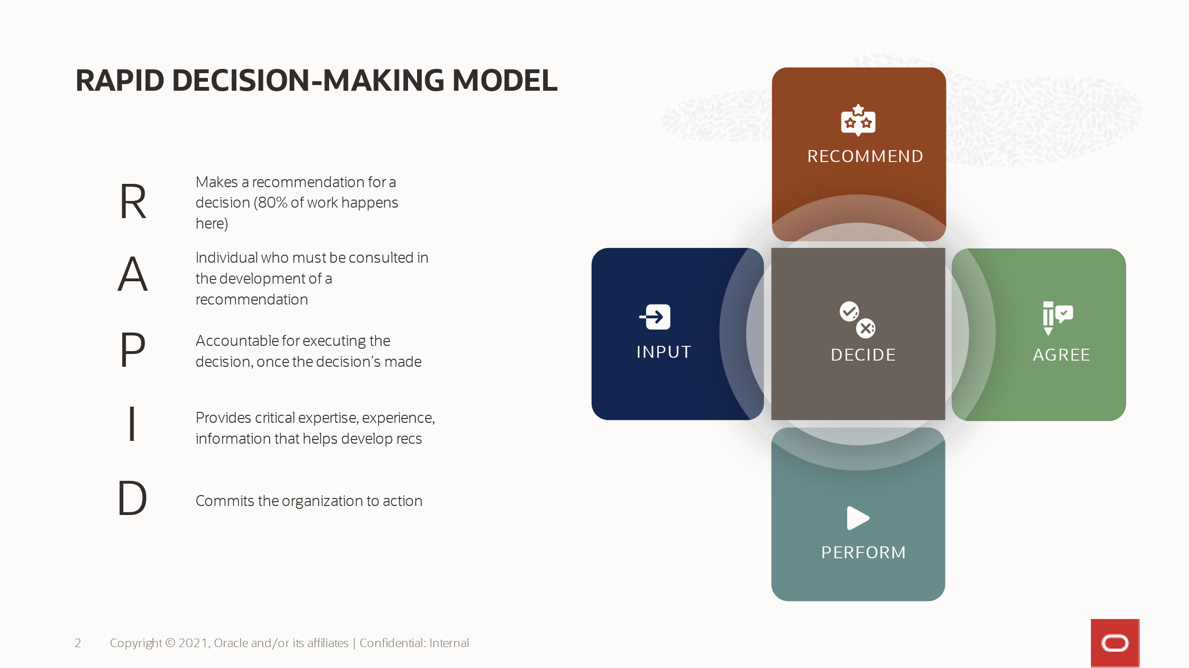
Appendix B: RAPID, In Practice
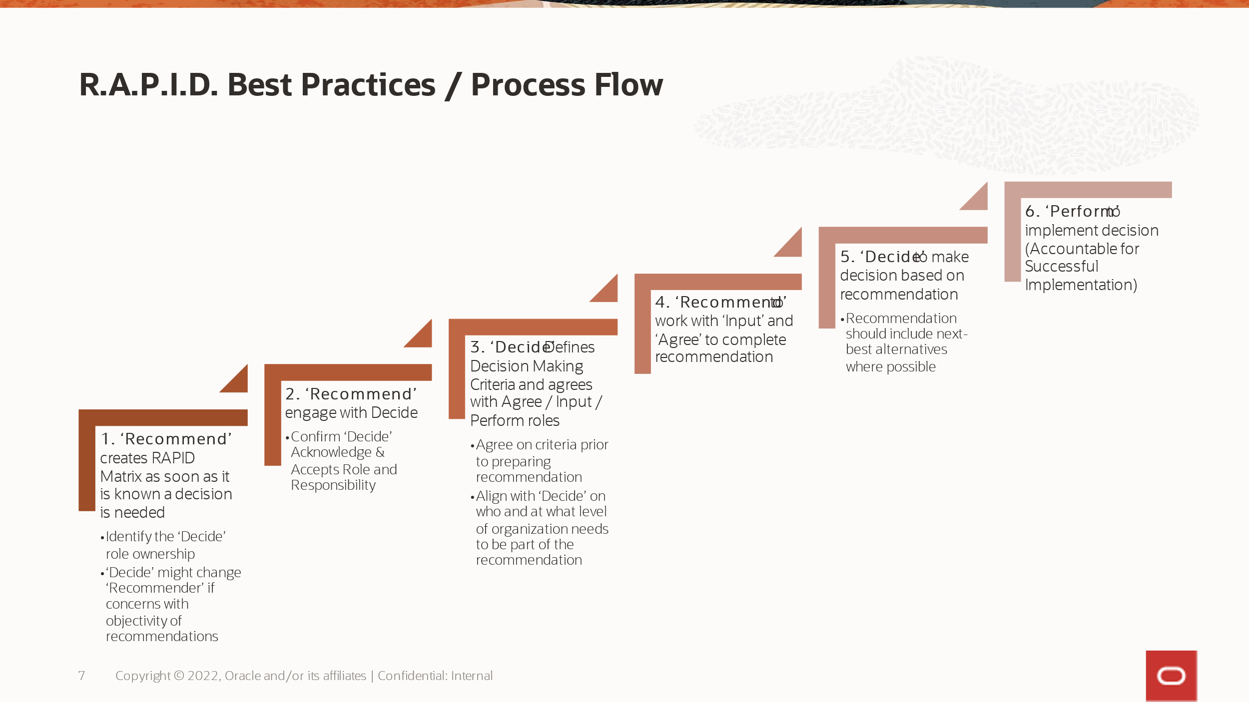

Appendix C: RAPID Template examples (one-off decisions complex multi-project workstreams)
C.1 Basic workstream RAPID
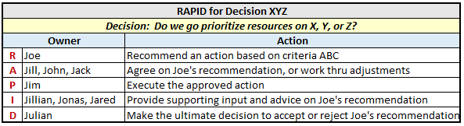
C.2 Recurring meeting / workstream RAPID
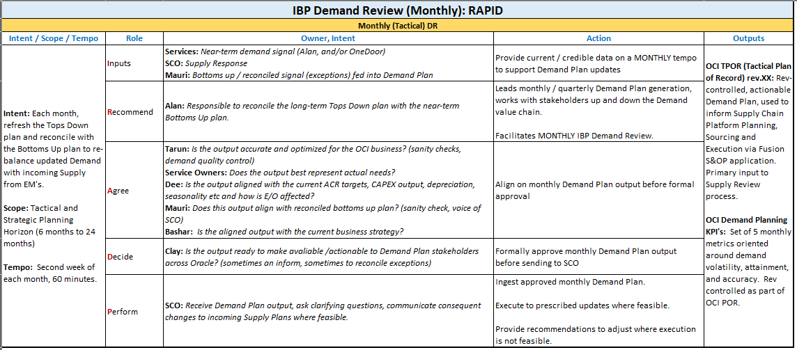
C.3 Complex multi-workstream RAPID
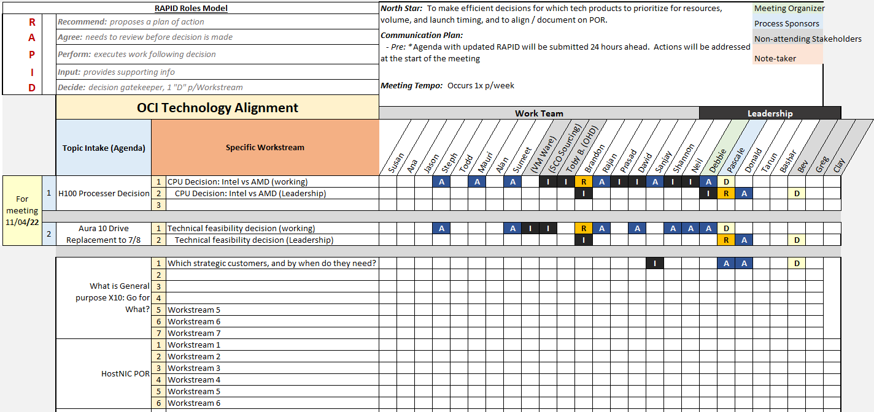
Appendix D: Meeting / Slack Etiquette Guidance (to be included in standard OCI Onboarding)
